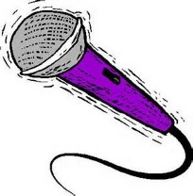
LBS IDOL TALENT SHOW
Registration For
Thursday, September 30, 2021
Friday, October 1, 2021
TIME: 1:00 – 1:30 PM
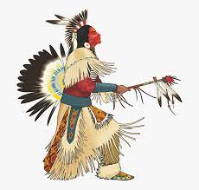

Name:
LBS PROGRAM:

EMAIL:

Please Choose Your Day:

Thursday, September 30, 2021:

Friday. October 1, 2021:

Please circle your talent.

Comedy Dance Poetry Singing Spoken Word Storytelling

Performances are two minutes each.

NOTE: PLEASE SUBMIT FORMS VIA EMAIL TO: Evadne@mtml.ca

